“Music is a science; it may be written; and the mode of conveying the ideas, is by signs and marks. A person may use the copy by playing it; but he has no right to rob the author of the profit, by multiplying copies and disposing of them to his own use.” Lord Mansfield in *Bach v. Longman* (1777)

**(Dis-)Owning the Sound: A Workshop on the Historical Development of Music Property & Authorship**

A Royal Society of Edinburgh Susan Manning Workshop  
(with a live concert kindly performed by staff and students from the Reid School of Music)

The Institute for Advanced Studies in the Humanities, The University of Edinburgh,

Organised by [Chen Wei Zhu](mailto:C.W.Zhu@bham.ac.uk) & [Jenny Nex](http://www.eca.ed.ac.uk/reid-school-of-music/jenny-nex)

Monday 16 June 2014

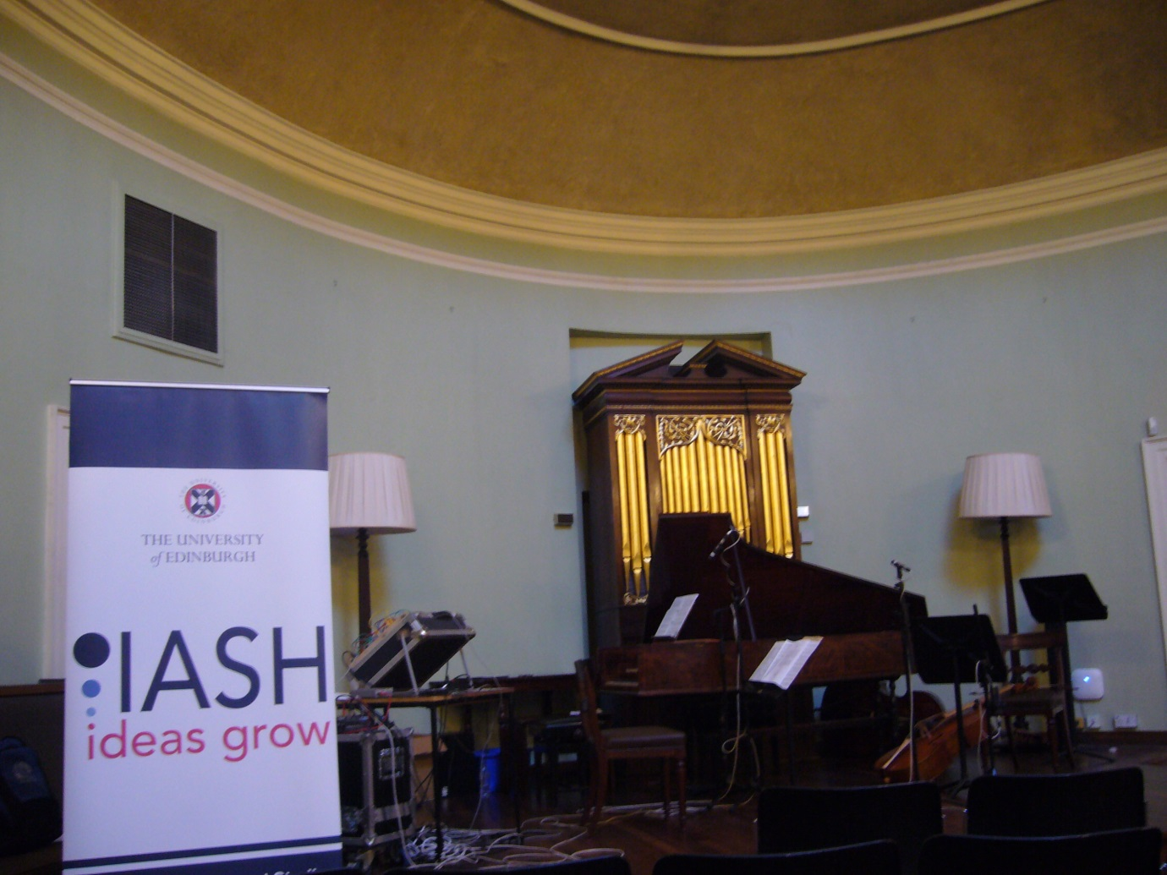

[**St. Cecilia’s Hall**](http://www.ed.ac.uk/schools-departments/information-services/library-museum-gallery/museums-and-galleries/musical-instrument-museums) **is the oldest purpose-built concert hall in Scotland and it also houses a rich collection of historical music instruments.**

**Workshop programme**:

Welcome from Professor [**John Cairns**](http://www.law.ed.ac.uk/people/johnwcairns) (Edinburgh Law School)

Session I (chaired by Dr. [**Smita Kheria**](http://www.law.ed.ac.uk/people/smitakheria), Edinburgh Law School)

**Chen Wei Zhu (IASH/University of Birmingham) “Lord Mansfield unwrapped: the significance of Bach v Longman in the history of music copyright”**

On 10 June 1777, Lord Mansfield, Chief Justice of King’s Bench, handed down an important ruling in *Bach v Longman*, which established statutory copyright in music under the 1709/10 Statute of Anne. Less than a week later, on Monday 16 June 1777, the rest of the King’s Bench ratified Mansfield’s decision. (By pure coincidence, this research workshop takes place on the same day and same date of the week 237 years later.) The plaintiff, Johann Christian Bach (1735-1782), also known as the “London” Bach, was Johann Sebastian Bach’s youngest surviving son. He went to London in 1762 and became one of the most prominent composers in Georgian England in the second half of the 18th century, though he never managed to achieve what Handel had achieved before him in the first half of the century. Winning this particular case seems to have been a one-off courtroom success for J.C. Bach, who failed to develop a fully-fledged Classical style in music. The task of forging and perfecting the Classical style was later fulfilled by, amongst others, his student Mozart. Charles Sanford Terry, in a biography written in the 1920s, laments that J.C. Bach “has slumbered in a neglected grave” compared with his other brothers’ (especially C.P.E. Bach) musical achievements. My paper explores the much overlooked music aesthetics of Lord Mansfield, and how it is reflected in this landmark music copyright ruling in relation to J.C. Bach’s music.

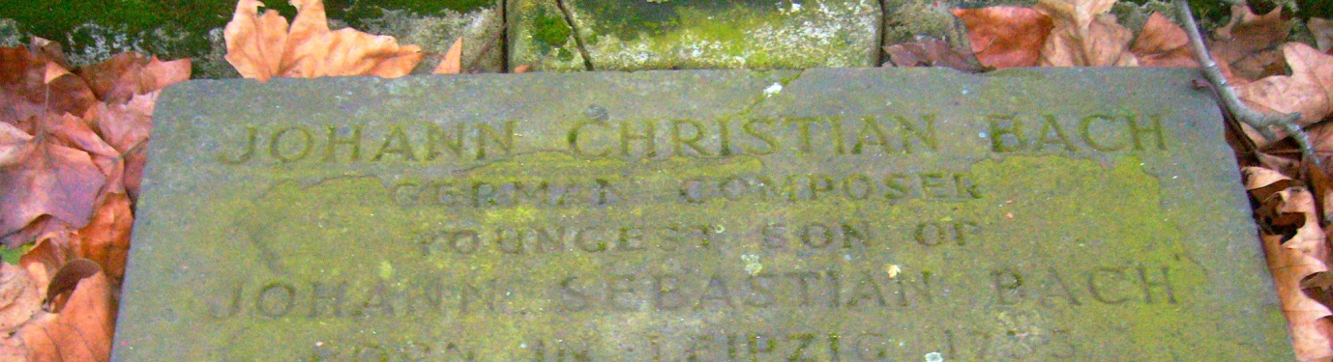

Entrance to St Pancras Old Church, where J.C. Bach and his music partner Carl Friedrich Abel (1723-1787) were buried. On 28th July 1968, the Beatles also visited this church during their “Mad Day Out” in London. [Photo](https://www.flickr.com/photos/chenwei/12161735574/in/set-72157640194918855) available under CC–BY–SA 3.0 by Chen Wei Zhu, January 2014

**Jenny Nex (Music Instrument Collections, UoE), “Longman, Lukey & Broderip: The (il)legal picture of their music publishing and musical instrument making business”**

The activities of the firm led by James Longman with his two partners Charles Lukey and Francis Fane Broderip were central to musical life in London for over thirty years, from the late 1760s to the early part of the nineteenth century, while their wider legacy can still be seen today. Their work encompassed all areas of musical life, from instrument making and dealing to music publishing, selling concert tickets and entertaining visiting musicians. They were also involved in numerous court cases relating to property rights of both printed music and musical instruments. These cases demonstrate the central issues facing the music trade at the end of the eighteenth century. The definition of and the ownership of the work itself was central, but issues relating to reversionary copyright, the publication of extracts, and acquiring and republishing music from abroad were also important. This paper uses Longman & Brodeirp as an example to explore issues of intellectual property in the late eighteenth century and the ways in which these litigations established the complex copyright laws we enjoy today.

**Sean Williams(Reid School of Music, UoE), “Distributed creativity in Karlheinz Stockhausen’s ‘Aus den Sieben Tagen’ ”**

See the below concert note on “Set Sail for the Sun”.

Session II (Chaired by Dr Chen Wei Zhu)

**Dr. Tom Tolley (Edinburgh College of Art, UoE) ‘A bloody harmonious war’: Haydn, Pleyel, and Copyright in Late Eighteenth-Century London**

‘A bloody harmonious war’ is Haydn’s punning description of the rivalry between the concert organization for which he worked in 1792, headed by the violinist Salomon, and the ‘Professional Concert’, whose star attraction at this time was Haydn’s former pupil, the composer Pleyel. Haydn’s choice of language, mixing musical and combative metaphors, reflects how newspapers projected this rivalry. While Salomon, for example, was regularly titled ‘Generalissimo ’, Pleyel was linked to William Braddyl, England’s leading advocate for pugilism. Even a legal setting for the imagined conflict was envisaged: ‘The NOTES of Haydn and Pleyel are likely to produce some discords in the Courts.’

Haydn and Pleyel really did find themselves in court in London, called as deponents in a lawsuit between two of their publishers. Although interpretation of this case has hitherto focussed on Haydn’s supposed misappropriation of compositions by Pleyel, evidence indicates that it was actually instigated to determine ownership of copyright, a matter of considerable significance to both composers contemplating the publication arrangements of their London commissions. Instrumental compositions by both men had previously been extensively published (and pirated) throughout Europe; but their respective compositions written specifically for the rival London concert organizations had distinct fortunes. Whereas Haydn’s London symphonies were soon widely disseminated through numerous publications and arrangements, the equivalent compositions by Pleyel, though fêted at first performance, were never published in their original form and essentially disappeared from view. The paper examines the copyright issues behind these contrasting fates.

**Dr. Lance Whitehead (independent scholar) “Robert Falkener: an eighteenth-century harpsichord builder, music publisher and malfeasant?”**

Our knowledge of the harpsichord maker Robert Falkener (fl 1760–80) rests largely upon the existence of two counterfeit harpsichords, and a lawsuit brought against him by Jacob Kirkman for forging six harpsichords. In addition to examining the possible reasons for applying a false inscription to a harpsichord at this time, this paper will also examine Falkener’s activities as a music publisher and his appearance in various court cases, with a view to determining whether his reputation as a rogue trader is deserved or in need of some re-evaluation.

**** **** Concert **** ****

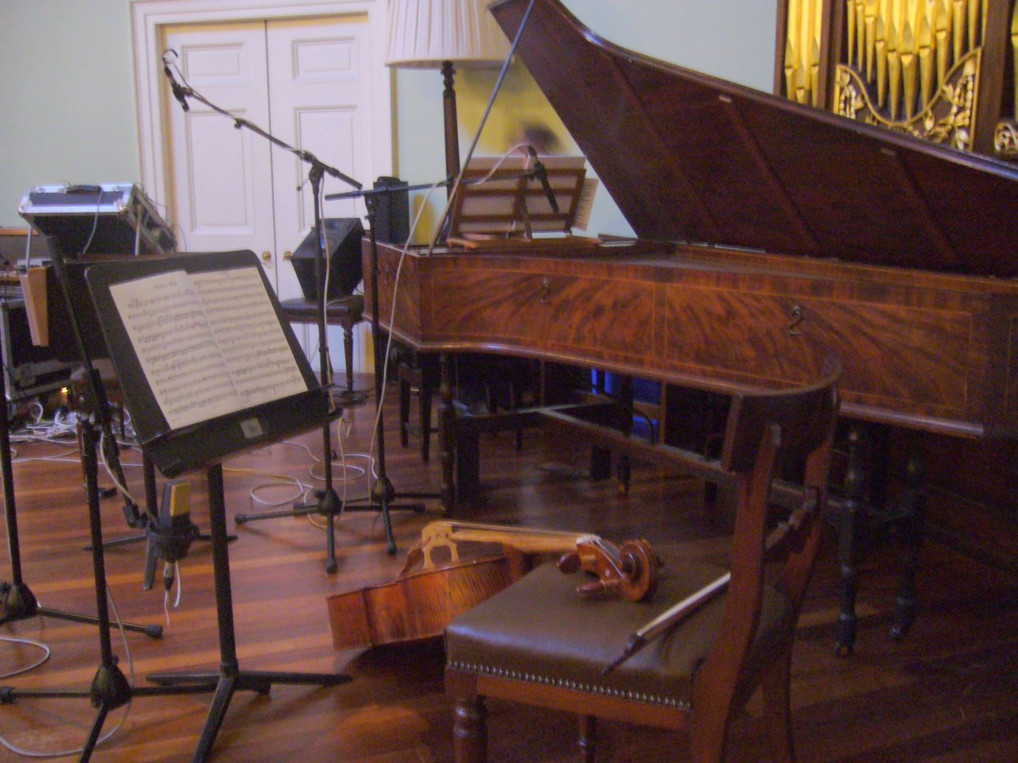

**The Workshop Concert, St Cecilia’s Hall**, St. Cecilia’s Hall Niddry Street, Cowgate, Edinburgh, EH1 1NQ

This workshop concert is arranged as an integral part of an RSE Susan Manning workshop on the historical development of music property and authorship at the Institute for Advanced Studies in the Humanities (IASH), University of Edinburgh. The concert programme is designed to bring to life the sonic dimension of the music that is discussed during the workshop. It is kindly performed by teachers and students from the Reid School of Music alongside special guests. Both the workshop and the concert are sponsored by the Royal Society of Edinburgh in memory of the late Professor Susan Manning (1953–2013).

**(I) Ignaz Pleyel (1757–1831)** **Trio in C major**

Catalogued as Hob.XV:3 by Franz Joseph Haydn

1. Adagio-Allegro 2. Rondo: Andante-Adagio ma non troppo-Andante-Allegro-Andante

Ignaz Pleyel was a star pupil of Joseph Haydn. In the 1780s, William Forster – Haydn’s publisher in London – issued his ‘Opus 40’, containing three keyboard trios which Haydn had sent him amongst a batch of his own compositions. Modern scholarship tends to believe that two of these three trios catalogued by Anthony van Hoboken as XV:3-4 were actually composed by Pleyel. Longman & Broderip acquired copies of the manuscripts from the publisher Artaria in Vienna and produced their own edition. The dispute between these two London publishers reveals an intriguing relationship between a music master and his apprentice in terms of music author-ownership in the 18th century. At this time, keyboard music would have been played on either the harpsichord or piano, depending in part on what was available to the player.

[Sound Track 1 is available under a Creative Common licence: [CC-BY-NC Scotland 2.5](http://creativecommons.org/licenses/by-nc/2.5/scotland/) ]

**(II) Stephen Storace (1762–96) Care donne che bramate**

Stephen Storace studied music in London and Italy, performing alongside his sister Nancy, who sang the role of Susanna in the first performance of Mozart’s Le nozze di Figaro. Storace composed this aria in 1787 for the character Lisetta to sing in Il re Teodoro in Venezia by Giovanni Paisiello. Lisetta sings of her many sweethearts, enjoying their flattery and little gifts. She accepts these things with a laugh but is not so naive as to let them make a fool of her. Nancy first sang Care donne at the King’s Theatre, Haymarket. Storace took Longman & Brodeirp to court in 1788 when they published the aria having entered it at Stationers Hall. They claimed to have done nothing wrong since they had purchased the rights from the theatre’s copyist Signor Micheli. They had sold half of their 100 copies, at 2s 6d each to the general public or 1s 8d to ‘the trade’ and denied any wrongdoing. Storace won the case in July 1789 and was awarded a token one shilling plus legal costs and an injunction against Longman & Broderip publishing the aria in question.

[Sound Track 2 is available under a Creative Common licence: [CC-BY-NC Scotland 2.5](http://creativecommons.org/licenses/by-nc/2.5/scotland/)]

**(III) Johann Christian Bach (1735–82) Sonata in G major**

‘A New Lesson for the Harpsichord of Pianoforte’

1. Allegro 2. Minuetto Con Variatione

This is an amalgamation of two of JC Bach’s sonatas as it was published by Longman & Lukey under the title ‘A New Lesson for the Harpsichord of Pianoforte’ in 1772. Longman & Lukey took the first movement from Bach’s Opus 17 Sonata IV and the second movement from Sonata I and added a new variation to the latter. In 1763, Bach had been granted a Royal privilege for exclusive publishing rights to his own music for 14 years. He began legal proceedings against Longman & Lukey in 1773 and, after various complications, in 1777 Judge Lord Mansfield found in Bach’s favour.

[Sound Track 3 is available under a Creative Common licence: [CC-BY-NC Scotland 2.5](http://creativecommons.org/licenses/by-nc/2.5/scotland/)]

**(IV) Will of Aberdeen, Sung by Mrs Hudson at Vauxhall**

Vauxhall is probably the best known of the pleasure gardens frequented by high (and low) society, where music formed a central part of the available entertainments. Mrs Hudson was also an oratorio singer and may be the Frances Hawkeswell, a mantua maker from York, who married French horn player William Hudson and then turned her attention to music. In publishing this piece, Robert Falkener was probably taking full advantage of the popularity of ‘Scotch songs’ in London in the late eighteenth century. He charged a penny a page, so it would have been easy for the middling classes to afford a copy.

[Sound Track 4 is available under a Creative Common licence: [CC-BY-NC Scotland 2.5](http://creativecommons.org/licenses/by-nc/2.5/scotland/)]

**(V) George Frideric Handel (1685–1759) Oh Had I Jubal’s Lyre from Joshua (1748)**

Unusually, Handel’s music remained popular after the composer’s death, most notably with the major commemoration concerts held at Westminster Abbey in 1784 (25 years after his death) and thereafter. Robert Falkener and other publishers took advantage of this and published their own editions of his music. Falkener’s version lacks the original string parts and is a tone below the original pitch. ‘Oh had I Jubal’s Lyre’ is sung by Achsah, daughter of Caleb, in the last scene of the final act of Joshua. Achsah expresses her joy at the victory of Othniel over Debir and her forthcoming marriage to the former. She compares her own musical abilities to those of Jubal, a descendant of Cain, who is said (in Genesis 4:21) to be the father of all players of the pipe and lyre. Miriam, who is also mentioned, was the sister of Moses and Aaron and is credited in Exodus with leading the Israelites in song following their deliverance from the Egyptians.

[Sound Track 5 is available under a Creative Common licence: [CC-BY-NC Scotland 2.5](http://creativecommons.org/licenses/by-nc/2.5/scotland/)]

**\* About the keyboard instrument used in this concert: A Double-manual harpsichord by Robert Falkener, London, 1773**

This instrument bears the inscription ‘Jacobus Kirkman Londini Fecit’ on its nameboard. However, Kirkman was in the habit of spelling his name ‘Kirckman’ in the Latin inscription on the front of his instruments. By looking inside, we can find some explanation of this anomaly in the pencilled inscription ‘Robert Falkener London Fecit 1773 September’. In 1771, Kirkman brought an action against Falkener for ‘exposing to sale a certain Harpsichord for a large sum of money to wit the Sum of £27.6s. as and for a harpsichord made by the said Jacob’. Since this court case precedes the instrument in date by some two years, it is not clear whether the two parties came to some agreement, or Falkener simply continued to apply other people’s names to his products in order to be able to charge higher prices. For example, in the 1770s small-scale maker Ferdinand Weber charged between £22 and £36 for a double manual harpsichord while a similar instrument by Shudi & Broadwood, Kirkman’s main rivals, cost up to £73 or more depending in part on the decoration. In any case, this is a fine example of a late eighteenth-century harpsichord with a five-octave compass (F1,G1 to f3), two sets of 8ft strings, one set of 4ft strings, a lute stop, buff and machine stop. It was almost certainly owned by General John Reid (1721–1807), who founded the Reid Chair of Music at the University of Edinburgh, and who bequeathed his instruments to the University with effect from 1839.

A Short Interval

**(VI) Karlheinz Stockhausen (1928–2007) “Set Sail for the Sun” from *Aus den Sieben Tagen* (1968)**

This is one of ‘15 text compositions for intuitive music in variable settings’ written in 1968 during a period of personal crisis. Most of the pieces were performed by the Cologne/Stockhausen Ensemble as part of their repertoire until the 1970 World’s Fair in Osaka and have been performed by many other groups since. In Osaka, the ensemble played Stockhausen’s music every day for 6 months, and in this concentrated atmosphere, the tensions inherent in the different creative practices required by these pieces strongly contributed to the demise of the group. During the World’s Fair, a letter was sent to Stockhausen by some members of the ensemble in which they essentially claimed ownership of the music, citing the fact that they were playing and creating their own music whilst nominally performing Stockhausen’s works. In recent interviews with surviving members of the ensemble, it has been suggested that some parts or even entire pieces in this collection were essentially transcriptions made by Stockhausen of practices or techniques that the ensemble members themselves had developed.

It should become clear that although the piece can be seen to have a unique identity or form, nevertheless, a great deal of creative input is required from the musicians to transform the text instructions into music. In order to give a fair recognition of creative input to each participant – including the composer – it becomes necessary to question existing models of creativity (and how they are reflected in copyright law). Although this is perhaps an extreme example, there is a strong case for arguing that the models of creativity relied upon for copyright are not fit for purpose and that in order to reflect interpreters and performers creative contributions to the musical output, new models of creativity are urgently needed.

[Sound Track 6 is available under a Creative Common licence: [CC-BY-NC Scotland 2.5](http://creativecommons.org/licenses/by-nc/2.5/scotland/)]

**\*Creative Common Licensing Notice**: *The concert recording is commissioned by Chen Zhu and Jenny Nex for the IASH (Edinburgh). All pieces are free for non-commercial use with appropriate attribution to the IASH and performers under* [*CC-BY-NC Scotland 2.5*](http://creativecommons.org/licenses/by-nc/2.5/scotland/) *Pieces I-V are performed by David Gerrard (harpsichord),* [*Emma Lloyd*](http://emmajanelloyd.com/about.html) *(violin),* [*Laura Sergeant*](http://laurasergeant89.wix.com/laurasergeantcellist) *(cello) and* [*Jenny Nex*](http://www.eca.ed.ac.uk/reid-school-of-music/jenny-nex) *(Soprano); Piece VI is performed by the ‘Grey Area’ Ensemble comprising Emma Lloyd (violin), Armin Sturm (Double Bass), Owen Green (Bowed Box) and* [*Sean Williams*](http://www.eca.ed.ac.uk/reid-school-of-music/sean-williams) *(Synthesizer). Sound recording by Kevin Kay; mixing & mastering by Sean Williams.*